Human Computer Interaction & GUI Programming

(ITP4506)

Group project

User Analysis Report

|  |  |
| --- | --- |
| Student name | ID |
| Cheng Alex | 180129424 |
| YU Chun Kit | 180111111 |

Table of content

**Content**

**User characteristics 3**

**Techniques for observing and listening to uses 5**

**Environment Analysis 6**

**Recruiting Users 7**

**Task Analysis 8**

**Web Design Concepts 10**

# User characteristics

Learning style

* **Normal user:**

Most of the normal users will just do-then-read that means they won’t read any manual before using the system. Thus, using simple designs and similar designs to most of the popular webs in the market, like sign-in/sign-out placed in the top right corner or cross sign for closing things, are important since users are accustomed to use system like that.

* **Operator:**

Since the job of operator is important and mistake should be avoided as possible as it can be. Operator would probably read the manual first to avoid making any mistakes.

* **Admin:**

Same as operator.

Tool preferences

* **Normal user:**

It is assumed that most of the users have experience in using similar webs or surfing the web. Therefore, some common UI elements such as slider, card view or rating bar are known by them

Since the range of user is very wide, providing mouse operator for them would make them easier to do the job

Intuitively.

* **Operator:**

Operators in the company are experienced in using similar system, so

Since efficiency would be one of the biggest concerns for operator, they would sometimes prefer using keyboard to perform task faster.

* **Admin:**

Same as operator.

Physical differences

* **Normal user:**

It is assume that all normal users are healthy enough so that they can use the electrical device to browse the take-away website.

* **Operator:**

The age of operators would be ranged from 18 to 50 and they

are all healthy with no handicap, like visual limitation or restrict movement.

* **Admin:**

Same as operator.

Cultural differences

* **Normal user:**

Since normal user are public, their education level will be largely different. Some of they may even be word-blind. But according to a survey conducted **by Social Indicators of Hong Kong\***, the adult literacy rate is 96% in the latest research. Due to the mandatory education in Hong Kong, it is believed that the rate will be increasing. Hence, we assumed all of our user are not word-blind, but we will use the word as simple as possible and use as many visual aids as possible to help those with low education level.

* **Operator:**

Operators are people with at least a secondary school diploma. So, their reading levels in English or Chinese is relatively high.

Also, they are experienced so they are familiar with most of the jargon in the industry.

* **Admin:**

Same as operator.

* https://www.socialindicators.org.hk/chi/indicators/education/7.7

Knowledge of the job

* **Normal user:**

Some of the user may use the web daily for seeing discount or ordering food. But, most of the user will not use the web daily.

The time they spend on the web will not be so long, when they finish viewing discount or ordering food, they will close the web.

Some of the food type may be rare and the user may not know but picture will be provided to assist the user.

* **Operator:**

Operators will use the web daily since they have to make sure the correctness of the information of the restaurant or food menu. When a new food menu/restaurant is added or incorrect information are reported, operator need to modify the data as soon as possible.

The time they spend will be so long, they have to use the web during the duty hours that will be mostly like 8 hours per day.

Moreover, the job will be so repetitive and tedious.

There will be some specialized vocabularies. However, operators are experienced so it shouldn’t be any problem.

* **Admin:**

Same as operator.

Primary user and Secondary user

* **Normal user:**

They are the primary user of the customer page.

* **Operator:**

They are the primary user of the operator page. They are secondary sometime when they want to modify their account, they will ask admin to do the job.

* **Admin:**

They are the primary user of the admin page.

Application familiarity

* **Normal user:**

Novice should be able use the website easily without any training or tutorial since the type of jobs are nicely separated and indicated with clear message.

But, on the other hand, expert won’t get significant boost in speed as most of the action are performed by mouse, there is no shortcut to speed up the process.

* **Operator:**

Novice may find it difficult to fully control the system.

Expert can fully control the system, they know most of the shortcut to speed up the process.

* **Admin**

Same as operator.

# Techniques for observing and listening to uses

Interview

For the customer page, we will invite about 30 people with different gender, age and visual ability to try some similar webs on the market and the prototype of our web and ask them which part of the web they like, which part they don’t like and are there any thing they want to be in the new web.

Similar thing will also be done to the operator and admin page.

Online surveys

Online survey will be conduct for the customer page. At the bottom of the customer page, there is a section for customer to give feedback to the company, customer can write the comment and send back to the company.

Role playing

Some of the operators and administrators will be selected to try using the web and give feedback on the web.

# Environment Analysis

* **Normal user:**

Normal user will use the web at home when using the restaurant/menu viewing function or food ordering function with a computer or mobile device.

Normal user will also use the web outdoor when they want to use the restaurant viewing function to find a restaurant they want in the street.

The time they use the web can be in daytime or at night, it doesn’t matter for the indoor occasion. But, for the outdoor occasion, the surrounding can be too light or too dark and the color be used in web should be adjust for those occasion.

* **Operator:**

Operators will use computer with keyboard and mouse in office from day to night. Since office is indoor it is easy to adjust the lighting to use the web comfortably and the place should be quiet.

* **Admin:**

Same as operator.

# Recruiting Users

We will invite people in the street to try to use the web and ask their feedback, a $50 food coupon will be given to them if they participate.

# Task Analysis

**Normal user:**

Register account

1. Click “sign-up” in the navigation bar
2. Input required information
3. Click “Register” button

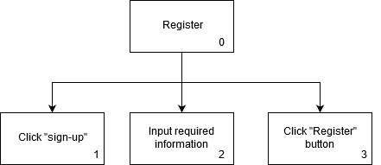

Login account

1. Click “sigh-in” in the navigation bar
2. Input username and password
3. Click Login

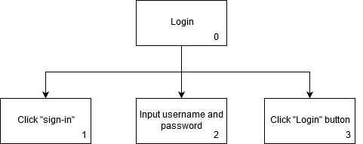

Forget password

1. Click “sign-in” in the navigation bar
2. Click “Forgot password” at the bottom
3. Input email and username
4. Click “Confirm” button

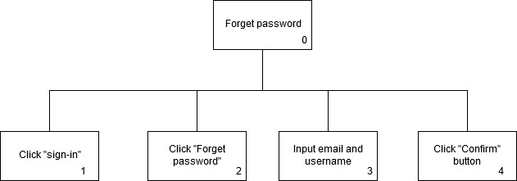

View menu

1. Find restaurant
   1. View restaurant
   2. Apply filter
      1. Click “Filter” button
      2. Input required information
      3. Click “Submit” button’
   3. Click restaurant
2. Find menu

Plan 0:

Do 1.1 - 1.2.1 - 1.2.2 - 1.2.3 – 1.3 – 2

If no need to use filter:

Do 1.1 – 1.3 - 2

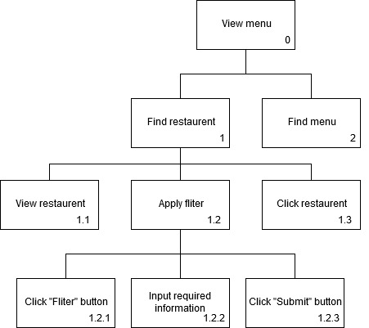

View restaurant

1. Read through restaurant list
2. Apply filter
   1. Click “Filter” button
   2. Input required information
   3. Click “Submit” button
3. Click restaurant

Plan 1:

Do 1 – 3

Plan 2:

Do 2.1 – 2.2 – 2.3 - 3

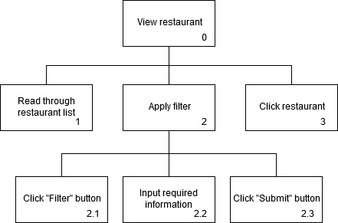

Order meal

1. Find restaurant
   1. Read through restaurant list
   2. Apply Filter
      1. Click “Filter” button
      2. Input required information
      3. Click “Submit” button
   3. Click restaurant
2. Add menu
   1. Read menu list
   2. Click “+” button
3. Check-out
   1. Click “Shopping Cart” in the navigation bar
   2. Enter quantity for ordered food and selected payment method
   3. Click “Order” button

Plan 0:

Do 1.2.1 – 1.2.2 – 1.2.3 – 1.3 repeat(2.1 – 2.2) – 3.1 – 3.2 – 3.3

If no need filter:

Do 1.1 – 1.3 – repeat(2.1 – 2.2) – 3.1 – 3.2 – 3.3

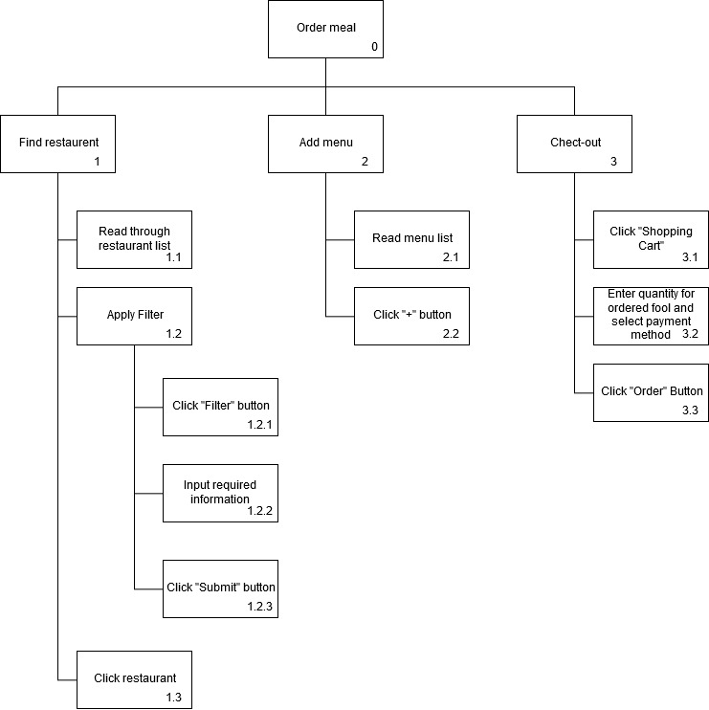

# Web Design Concepts

Mental Modal

Admin page

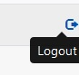

Most of the web today using icon like

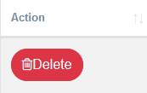

The rubbish bin icon will make user associate the button with discarding something that is similar to deleting thing. Also, the most popular operating system in the world, Windows series, use a recycle bin icon for saving non-permanent deleted data. So user have a high chance thinking of the rubbish icon is deleting thing.

Customer page



Affordance

Content Organization

**Customer:**

Navigation bar



The navigation bar of customer use **task-oriented** **organizational scheme** to group the content.

Restaurant container

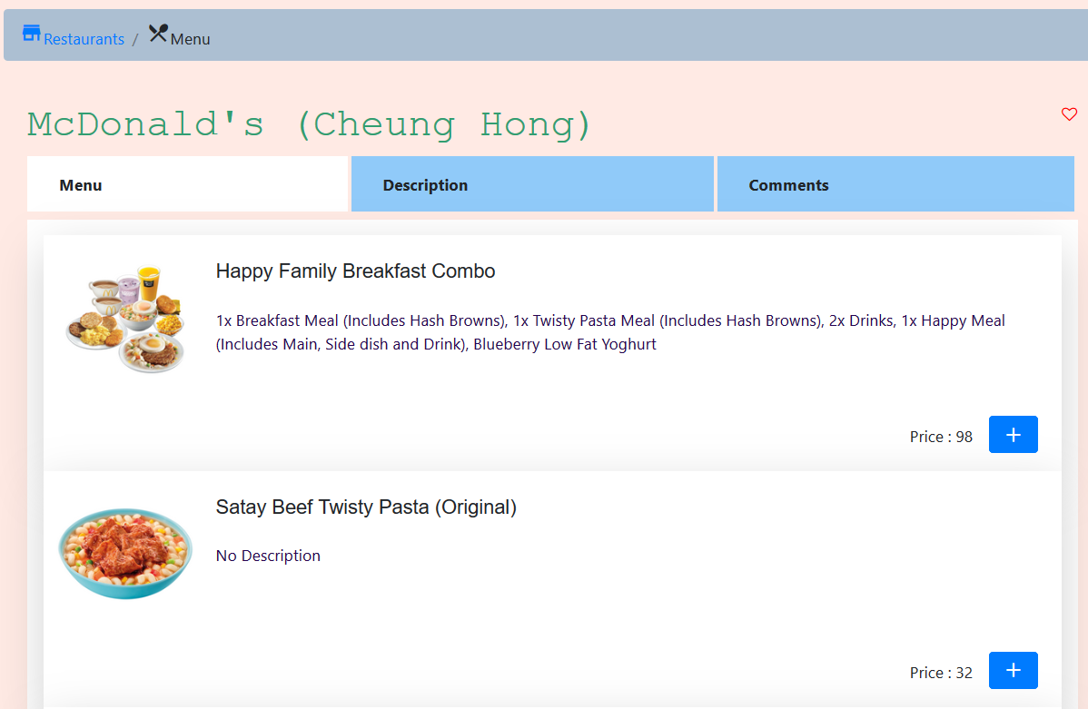

The container for showing restaurant information use **topical** **organizational scheme** to group the content.

**Operator**

Sidebar

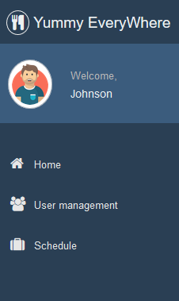 

The sidebar of the admin page use **task-oriented organizational scheme** to group the content.

**Operator**

Navigation bar

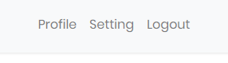

The navigation bar of the operator page **use test-oriented** **organizational scheme** to group the content.

Visual Organization

Alignment

Admin login page

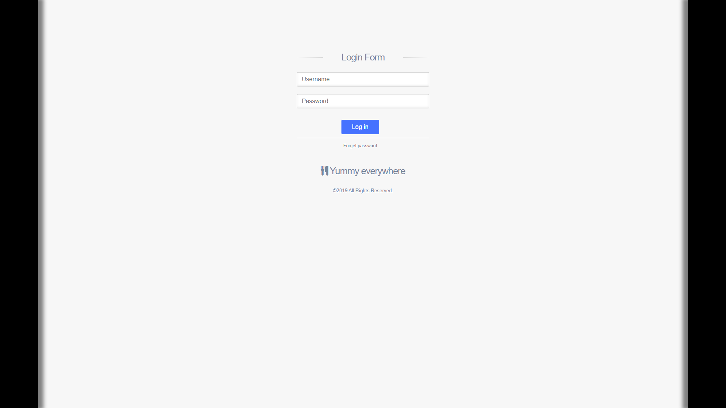

The login page of the admin shows that, those input boxes are **justified** and othercontentsare **centered.**

Consistency

**Admin:**

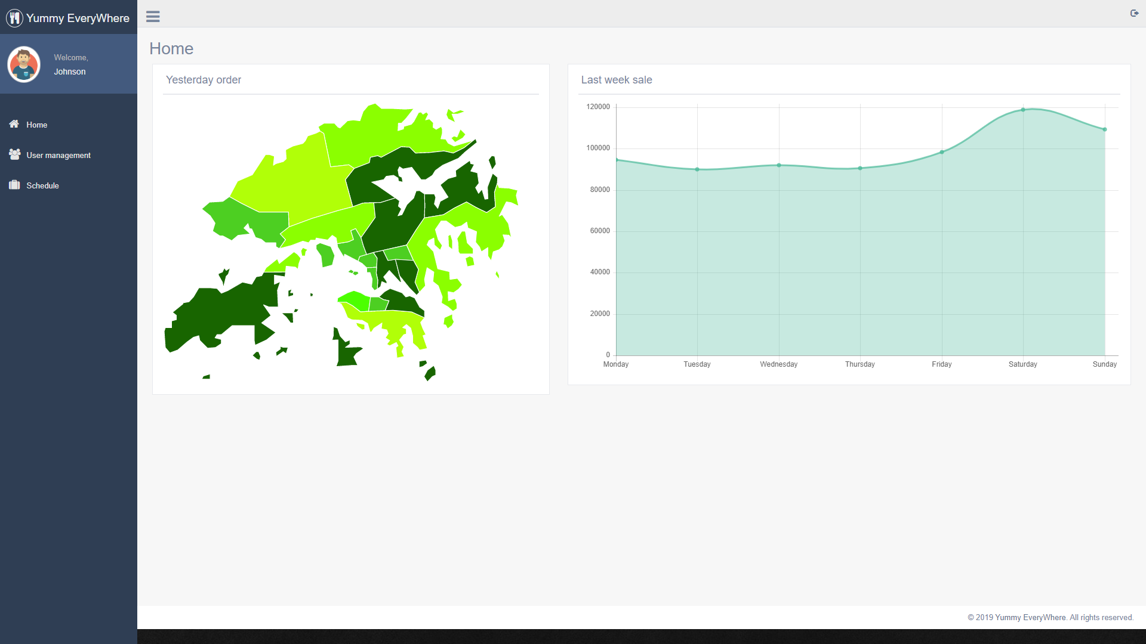

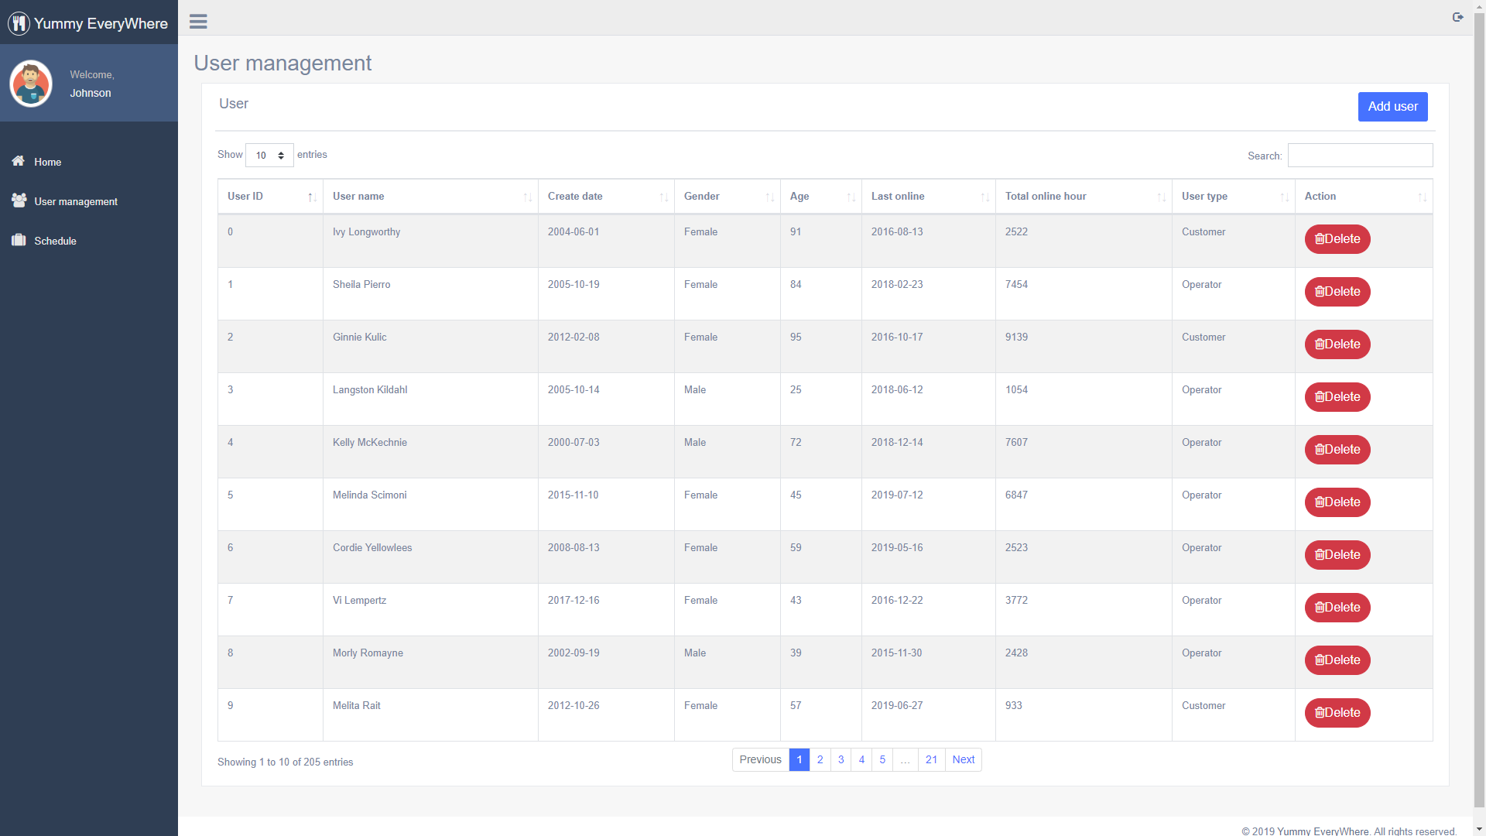

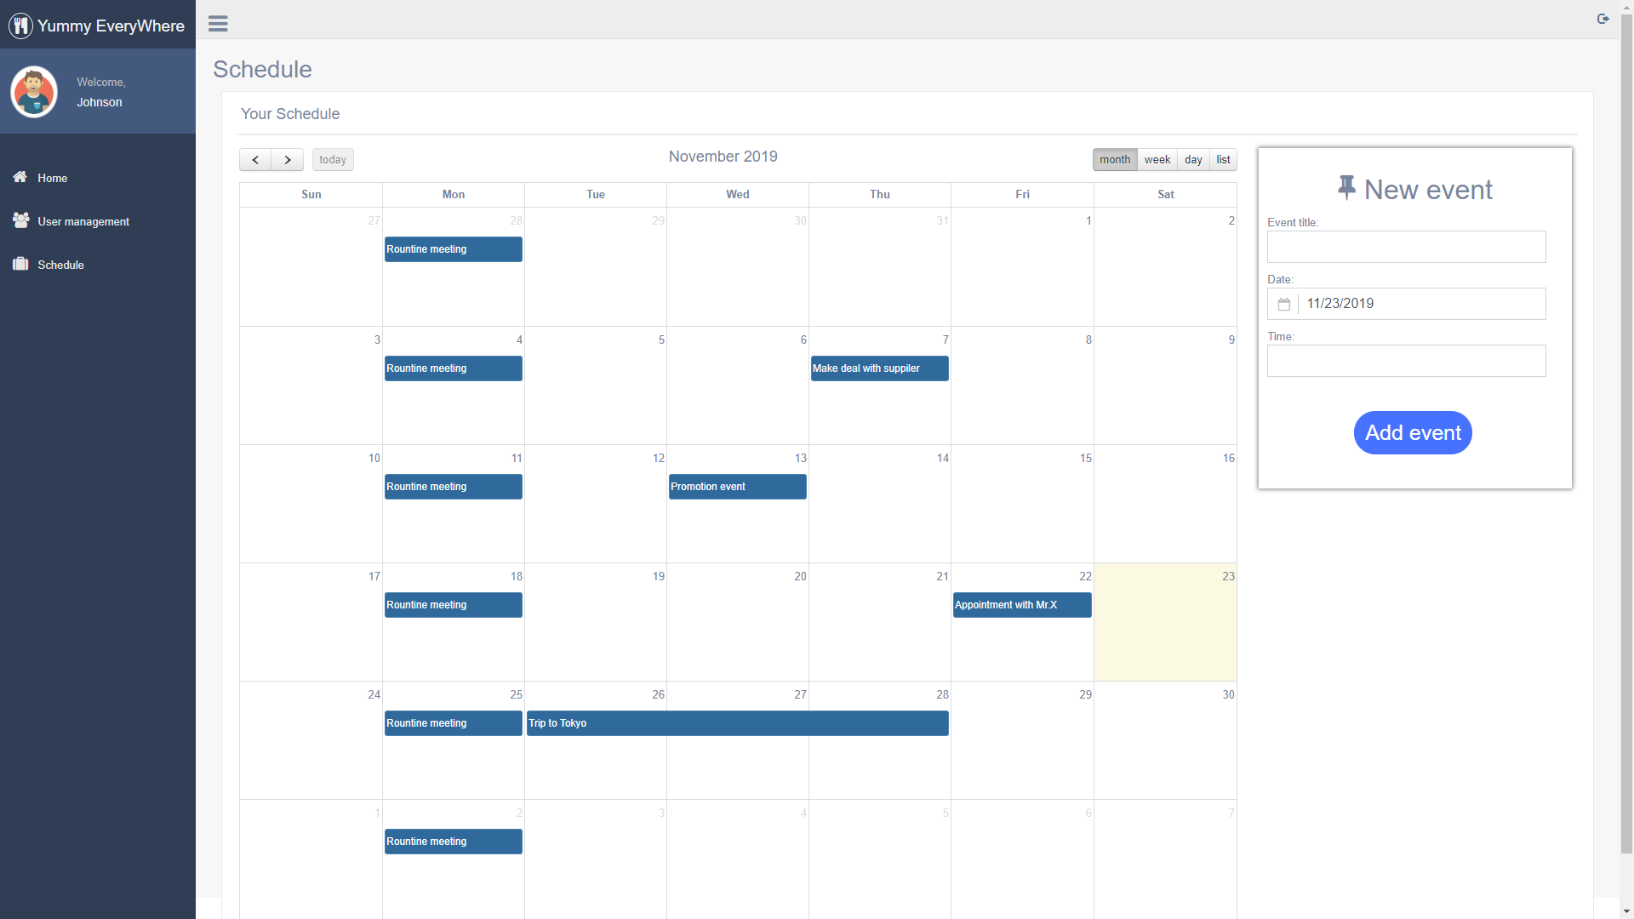

As the above images show, the color used in all admin page are consistent, they are mainly white for background or blue button or other element.

Contrast

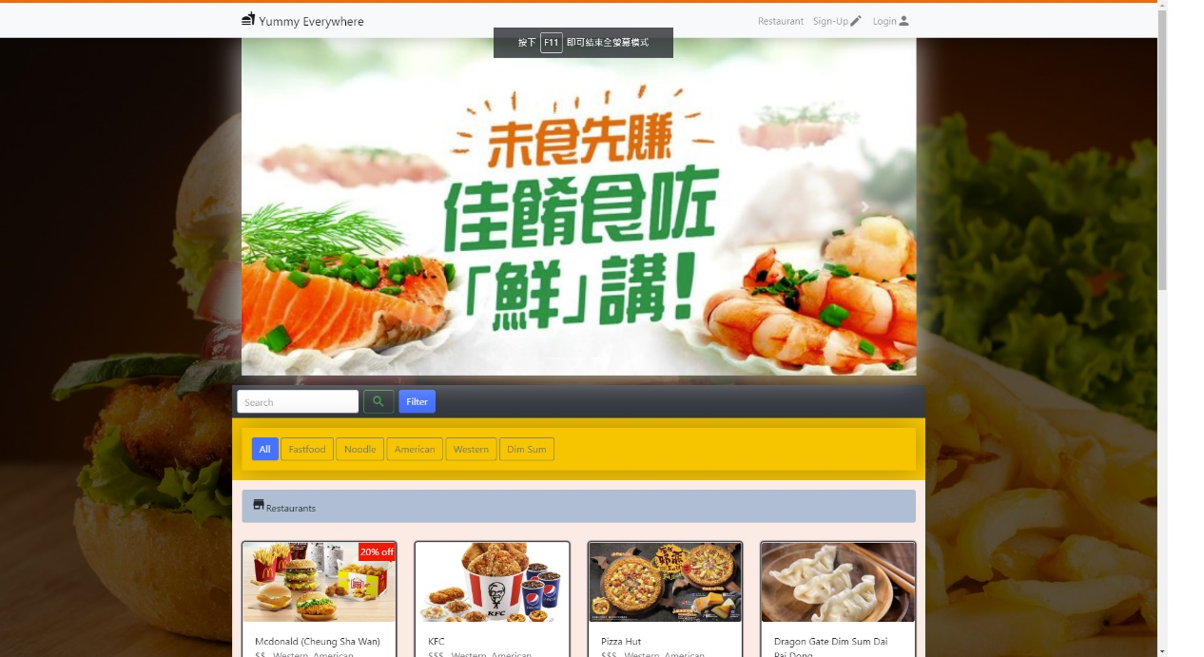

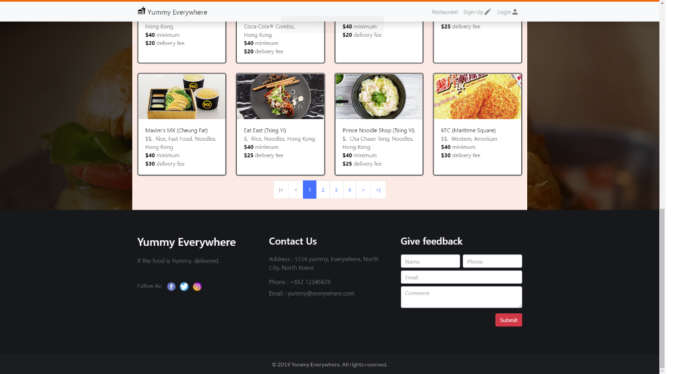

In the main page, different kind of items are nicely separated. As the figure above show, the upper part of the web is about some promotion, the second part of page is information of restaurant and the last part of the page is the information of the company.

Navigation

Hierarchical

Customer:

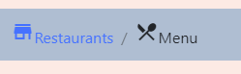

Operator:

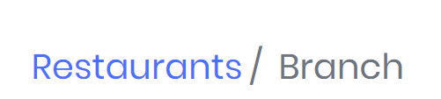

Breadcrumbs are used in operator and customer page and are added with a hyperlink for user to go back to the upper topic.

Ad hoc

Customer:



Operator:



Admin:

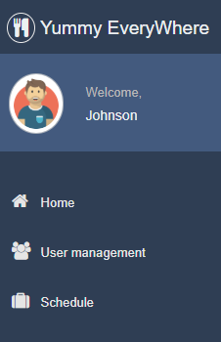

The navigation system used the most among these pages are ad hoc. As the pictures above show, navigation between different page are done by clicking hyperlink inside the navigation bar.